3GPP TSG-RAN WG1 Meeting #125 R1-2604280
Dalian, China, May 18 – 22, 2026

Agenda item: 10.8.1
Title: Discussion on 6G ISAC Evaluation
Source: National Institute of Standards and Technology (NIST)
Document for: Discussion and Decision

Introduction

During the past RAN1#124bis meeting, the baseline sensing targets, carrier frequency, and deployment scenarios for the sensing evaluation were agreed upon. In addition, companies shared views on sensing-assisted communication and evaluation assumptions. The feature lead also outlined plans for RAN1#125 as follows:

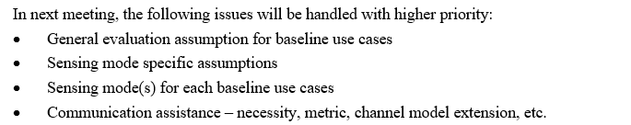

In this contribution, we provide our views on these aspects.

Sensing Modes
During RAN1#124bis, the following baseline use cases have been agreed upon:

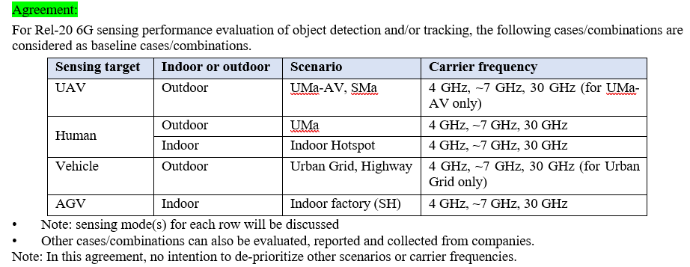

The scope of this study includes all six sensing modes. However, given the large number of combinations of sensing targets, their corresponding sensing scenarios, carrier frequencies, and sensing modes, it makes sense to perform some down-selection to facilitate the collection and comparison of evaluation results. For each sensing scenario, more promising sensing modes, i.e., those with a high probability of LoS or a direct path, can be selected as the baselines, and it is up to the company to simulate the remaining sensing modes.

In the 5GA study, we evaluated TRP monostatic sensing for UAVs at heights between 25 m and 300 m. In the 6G evaluation, we can include TRP bistatic sensing to mitigate the challenge of high self-interference.
Similarly, for ground targets such as humans or vehicles, TRP-UE and UE-TRP sensing should be prioritized because the targets are less visible to TRPs.
With these considerations in mind, we propose the following sensing modes for each use case.
For the urban grid and highway scenarios, we also propose UE monostatic and UE-UE bistatic sensing; the UE here could be an RSU-type UE or vehicle UE.

Proposal 1: The following sensing modes for each baseline use case could be considered:

Table 2-1: Baseline Sensing Modes

Sensing Target | Indoor or Outdoor | Scenario | Carrier Frequency | Sensing Mode
UAV | Outdoor | UMa-AV, SMA | 4 GHz, ~7 GHz, 30 GHz (for UMa-AV only) | TRP monostatic, TRP-TRP bistatic
Human | Outdoor | UMa | 4 GHz, ~7 GHz, 30 GHz | TRP-UE bistatic, UE-TRP bistatic
 | Indoor | Indoor Hotspot | 4 GHz, ~7 GHz, 30 GHz | TRP-UE bistatic, UE-TRP bistatic, TRP monostatic
Vehicle | Outdoor | Urban Grid, Highway | 4 GHz, ~7 GHz, 30 GHz (for Urban Grid only) | TRP-UE bistatic, UE-TRP bistatic,  UE monostatic, UE – UE bistatic
AGV | Indoor | Indoor factory (SH) | 4 GHz, ~7 GHz, 30 GHz | TRP monostatic, UE-TRP bistatic, TRP-UE bistatic

Note that, in the urban Grid and Highway case, the UE can be an RSU-type UE or a vehicle UE.

Evaluation Assumptions
For the 5G-Advanced ISAC evaluation, we conducted a comprehensive study to define the evaluation assumptions and specify the evaluation methodologies. The evaluation methodologies can serve as a starting point for the 6G sensing evaluation.
Proposal 2: The 5G-A ISAC evaluation methodology can serve as a starting point for discussing 6G sensing evaluation.

In this section, we are going to discuss the evaluation assumptions for the following aspects:
- Sensing deployment and UE distribution
- Sensing Target deployment
- Antenna configurations
- Simulation configurations

3.1 Sensing Deployment and UE Distribution
For TRP deployment and UE distribution, TR38.914, which includes Urban macro, Sub-Urban macro, Urban grid, and Indoor Factory scenarios, can serve as a starting point for discussion. For other UE types, such as CPE and RSU-type UE, the distribution in TR38.859 can serve as a starting point.
Proposal 3: Consider Table 3-1, which is based on TR38.914 and TR38.901, for sensing deployment and UE distribution for each scenario.
Table 3-1: Sensing Deployment and UE Distribution
Scenario | Deployment | Sensing UE distribution as the sensing entity | Mobility and Height of Sensing UE
SMa | 38.901 Sub-Urban macro, single-layer hexagonal grid, ISD 1299 m or 1732 m  BS antenna height 35 m | Distribute UEs uniformly within each cell  All UEs are outdoor UEs  FFS: Number of UEs
UMa, Uma-AV | 38.914 Urban macro, macro ISD 500 m  7 x 3, single layer, hex grid  BS antenna height 25 m | Distribute UEs uniformly within each cell  All UEs are outdoor UEs  FFS: Number of UEs | Handheld: 1.5 m  Handheld: [0 km/h]
Indoor Hotspot | 38.914 indoor hotspot, open office 120 m × 50 m, ISD 20 m, 12 TRxPs  Indoor Hotspot: 3 m (ceiling) | Distribute sensing UEs uniformly over the office floor.  Baseline: [10] sensing UEs per TRxP, all on the same floor | 100% indoors, [0 km/h]; UE height about 1 m;
Urban Grid | 38.901 Urban grid,  Urban grid road geometry as 2 lanes in each direction, lane width 3.5 m, road grid size 433 m × 250 m, with 3 m sidewalk reserved per direction  BS antenna height 25 m  38.914 Urban Grid, road-block model, ISD 500 m or 250 m | Use a heterogeneous sensing UE set: vehicle sensing UEs deployed on traffic lanes, pedestrian sensing UEs placed on sidewalks, and, optionally, RSU-type sensing nodes at intersections. | 100% outdoor; vehicle UEs follow lane-constrained motion; baseline vehicular speeds are up to 50 km/h and 120 km/h;  pedestrian UEs move at 3 km/h  Handheld: 1.5 m  Vehicle: 0.75 m (Type 1, low antenna position) or 1.6 m (Type 2, high antenna position)  RSU: 5 m  Handheld: [0 km/h]  RSU: [0 km/h]  Vehicle: 60 km/h in all the lane
Highway | 38.914 Highway scenario, BSs only around highway sides, ISD 500 m or 1732 m  38.901 Highway scenario; highway geometry of 3 lanes in each direction, that is 6 lanes in total, and highway length at least 2000 m  BS antenna height 35 m for ISD 1732 m, 25m for ISD 500 m | Distribute sensing UEs on lane centerlines as vehicle UEs. If roadside sensing entities are allowed, add RSU-type UEs uniformly every 100 m in the freeway median region | 100% in vehicles; baseline in 38.914 is either 85% at 120 km/h plus 15% at 200 km/h, or 100% at 140 km/h; average inter-vehicle spacing is 2 second × speed  Vehicle: 0.75 m (Type 1, low antenna position) or 1.6 m (Type 2, high antenna position)  RSU: 5 m
Indoor Factory (InF-SH) | 38.914 InF-SH, hall 300 m × 150 m, 18 TRxPs, spacing 50 m  BS antenna height 8 m | Uniformly distribute sensing UEs over the convex hull of the TRP deployment, effectively over the factory floor. Baseline: 30 sensing UEs | 100% indoor; UE height 1.5 m; minimum 2D TRP-UE distance 1 m; mobility can follow human [3 km/h, stationary machine profile 0 km/h, or AGV [30 km/h]

3.2 Sensing Target Deployment
We can divide UEs into two categories: 1) static UEs, including static handheld UEs, RSU-type UEs, and CPEs, and 2) mobile UEs, including vehicle UEs and pedestrian UEs. In 38.914, UE mobility is specified for vehicular UEs (up to 120 km/h) and pedestrian UEs (3 km/h). Studying both static and mobile UEs is important. However, we believe that sensing with static UEs should serve as a baseline, as it is more likely to yield reliable results. Based on the channel model calibration assumptions, we propose using the following target deployment to start the discussion.
Proposal 4: For target modeling, we propose Table 3-2 for consideration:
Table 3-2: Sensing Target Deployment
Baseline Scenario | UMa-AV, SMa | UMa | Indoor Hotspot | Urban Grid | Highway | Indoor Factory (InF-SH)
Sensing Targets | UAV | Human | Human | Vehicle | Vehicle | AGV
Target Deployment | N=5 targets uniformly distributed in the center cell  Vertical distribution: Uniformly distributed 25-300m | N=5 targets uniformly distributed within one cell | N=5 targets uniformly distributed over the horizontal area of the convex hull of the TRP deployment | N = 2 targets per lane of each side surrounding the center grid, for a total of 16 targets. | N targets per lane, for a total of 6N targets.  FFS: N = 2 or N = 3 | N=5 targets uniformly distributed over the horizontal area of the convex hull of the TRP deployment.
Target Velocity | Horizontal plane: Uniform between 0 and 180 km/h  Vertical plane: [0km/h] | 0 km/h, 3 km/h, or uniform between 0 and 10 km/h, with horizontal straight-line trajectory in random direction. | 0 km/h, 3 km/h, or uniform between 0 and 3 km/h, with horizontal straight-line trajectory in random direction. | 60 km/h in all lanes | 140 km/h in all lanes | 3 km/h, 10 km/h, or uniform upto 30 km/h, with horizontal straight-line trajectory in random direction.
Physical Characteristics, e.g., Size | Small Size: 0.3m x 0.4m x 0.2m  Large Size: 1.6m x 1.5m x 0.7m (optional) | Adult: 0.5 m × 0.5 m × 1.75 m | Adult: 0.5 m × 0.5 m × 1.75 m. | Type 2 (passenger vehicle: 5 m x 2 m x 1.6 m)  Vehicle type distribution follows TR 37.885 Option A i.e., 100 % type 2 vehicles. | Type 2 (passenger vehicle: 5 m x 2 m x 1.6 m)  Vehicle type distribution follows TR 37.885 Option A i.e., 100 % type 2 vehicles. | Small Size: 0.5m x 1.0m x 0.5m  Large Size: 1.5 m x 3.0m x 1.5 m (optional)

Proposal 5: When evaluating UE-involved sensing, static UE sensing can serve as a baseline and is more likely to produce reliable results.
Proposal 6: Sensing with UEs in motion should be further evaluated in the study to represent both pedestrian and vehicle UEs.

3.3 Antenna configuration-related simulation assumption
Regarding antenna configuration, the TRP's antenna configuration can use the assumptions agreed upon in the 5GA study as a baseline.
Table: 5GA Evaluation BS Antenna Configuration Assumption [TR38.765]
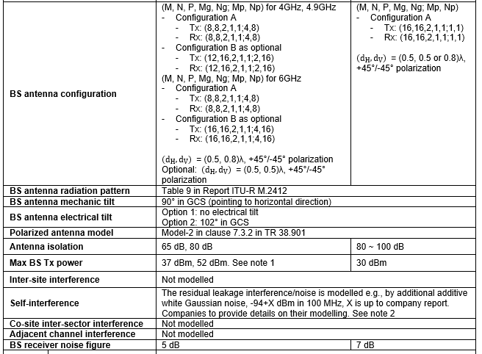

Proposal 7: For 6G sensing evaluation, the TRP antenna configuration can use the 5GA agreement as a starting point.
For the 6GR evaluation, the UE antenna modeling has been agreed upon in RAN1#124 for both carrier frequencies below 30 GHz and around 30 GHz [1]. The antenna modeling includes TX and RX antenna configurations and antenna-element radiation patterns. These agreements could serve as a starting point for discussing 6G sensing. For bistatic sensing, since angle estimation is important for target detection and parameter estimation, UE configurations with multiple antenna elements or RF chains can be considered as the baseline for evaluation.
Proposal 8: For the CPE and handheld UE, antenna configurations can be based on the 6GR UE antenna configurations [1].
Proposal 9: For other types of sensing UEs, such as RSU-type UE and vehicle UE, TR37.885 can be used as a discussion starting point

3.4 Sensing mode-related simulation assumption
For TRP monostatic sensing, we view the simulation assumptions agreed upon in the 5G-A study item as a robust starting point for 6G evaluations. Specifically, we can reuse the BS antenna isolation, maximum transmit power, and self-interference assumptions established in the 5G-A study.
Proposal 10: For TRP monostatic sensing, the simulation assumptions, such as self-interference modeling, antenna isolation, and maximum transmit power, can reuse the 5G-A ISAC evaluation assumptions as a starting point.
For UE as a sensing node, we observe that UE monostatic performance is heavily dependent on specific RF characteristics, including self-interference and isolation constraints, which require dedicated discussion. For sensing UE position modeling, we propose a tiered evaluation approach: starting with a baseline of perfect knowledge of the sensing UE’s location, velocity, and orientation, and then extending the evaluation to incorporate modeling errors for these parameters.
Proposal 11: For the evaluation of UE-based sensing, the following modeling assumptions should be considered:
- Baseline: Ideal knowledge of the UE’s state (location, velocity, or orientation) may be assumed as a starting point.
- Realistic Scenarios: To reflect practical deployments, modeling errors and uncertainties for these parameters (e.g., location, velocity, or orientation) should be incorporated into the evaluation.
Furthermore, for multi-node scenarios such as bistatic or multistatic sensing, we suggest assuming ideal time synchronization to establish a clean baseline. The impact of synchronization errors should also be studied to characterize performance degradation in realistic deployment scenarios.
Proposal 12: To ensure a comprehensive and realistic evaluation of sensing performance, the modeling framework shall include:
- Baseline: Ideal time synchronization to establish an upper-bound performance reference.
- Realistic Scenarios: To reflect practical scenarios, modeling synchronization errors among sensing nodes should be incorporated into the evaluation.

3.5 Simulation Configurations
Furthermore, to enable consistent cross-company evaluation, the simulation configurations should be aligned. Establishing a common baseline for these variables is a prerequisite for apples-to-apples comparisons and for benchmarking potential performance improvements. The sensing-related evaluation parameters could include:
- Baseline sensing nodes participated in the sensing
- Baseline beam configurations at the transmitter and receiver
- Baseline sensing reference signal and its RE mapping
- Baseline timeslot configuration
- Baseline CPI duration and its periodicity
Proposal 13: To facilitate consistent cross-company evaluation, a common baseline for sensing-related evaluation parameters should be established, including 1) Participated sensing nodes, 2) Beam configurations at each sensing node, 3) Sensing reference signal and its RE mapping, 4) Timeslot configuration, and 5) CPI duration and its periodicity.

Other Sensing Evaluation Considerations
In the Rel-19 channel modeling study item, four types of targets, i.e., UAV, human, vehicle, and AGV, have been modeled, along with the static background channel. For this sensing study, due to the expanded scope, it is necessary to extend the ISAC channel model to enable the study or to evaluate performance in a more realistic setup.
The static background channel models established in Rel-19 do not adequately capture the complexities of real-world clutter suppression. Reliable target detection and parameter estimation, such as Range-Doppler analysis, fundamentally depend on the ability to distinguish moving targets from environmental reflections. While static clutter can be easily mitigated through simple DC removal or zero-Doppler filtering, dynamic clutter, such as swaying vegetation or moving non-target objects, can cause a significantly higher interference floor. Additionally, integrating UE-based sensing in 6G introduces a non-stationary channel environment due to the sensing platform's inherent mobility. Therefore, modeling dynamic clutter and spatial-temporal non-stationarity is crucial for accurately validating sensing performance in realistic 6G deployment scenarios.
Proposal 14: The 6G ISAC evaluation assumption should include modeling dynamic clutter and platform-induced non-stationarity to accurately capture the challenges of target detection in non-stationary sensing environments.
Micro-Doppler denotes the Doppler modulation induced by internal target motion superimposed on the target's bulk motion. Representative examples include the rotation of UAV propellers and periodic human body motions such as breathing, heartbeat, and gait. Micro-Doppler modeling is relevant to target detection because conventional range-Doppler processing primarily relies on target bulk radial motion, while returns near zero Doppler are often treated as static clutter and may therefore be removed.
From a detection perspective, micro-Doppler may improve the observability of targets with negligible translational motion. As illustrated in Fig. 2.1, a seated human may still generate a measurable micro-Doppler signature due to chest movement from breathing and heartbeat. This indicates that target micro-motion can produce detectable Doppler fluctuations even when the target’s bulk velocity is close to zero. Therefore, neglecting micro-Doppler in the evaluation assumptions may underestimate the detectability of zero-velocity targets, such as hovering UAVs with negligible translation motion and stationary humans with no gross body movement.
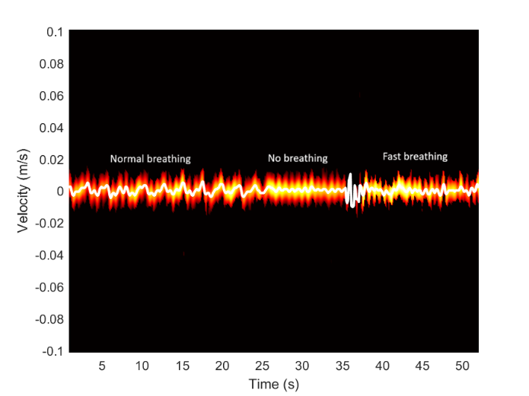
Figure 2.1 Micro-Doppler signature of a human (sitting position) with no other body movement.

From a target identification perspective, micro-Doppler provides discriminative features that can distinguish targets with different motion characteristics. As shown in Figs. 2.2(a) and 2.2(b), a moving AGV and a moving human produce different Doppler temporal behaviors. The AGV behaves approximately as a rigid body and maintains a nearly constant Doppler shift throughout its trajectory (time). In contrast, the human target exhibits time-varying Doppler fluctuations caused by natural gait dynamics. These observations suggest that target-specific micro-motion may provide useful information for target identification and classification applications.

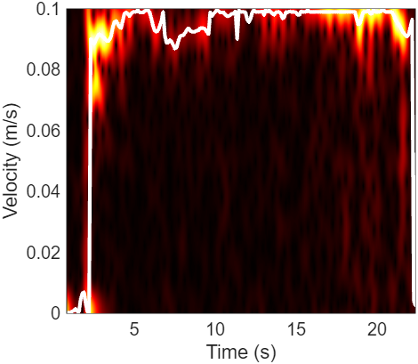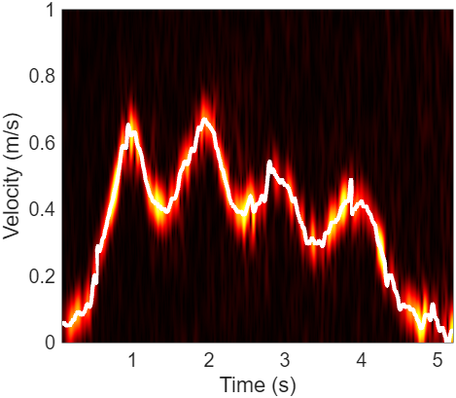
- AGV (b) human
Figure 2.2 Doppler signatures of the AGV and Human moving in a straight line towards a quasi-monostatic transmitter and receiver

In view of the above, it is proposed to incorporate target-specific micro-motion models. These models would allow for a more accurate assessment of detection performance for zero-velocity targets and would also support evaluating target identification applications based on micro-Doppler features.
Proposal 15: Incorporate target-specific micro-motion models into the evaluation assumptions to enable the assessment of zero-velocity targets, including hovering UAVs and stationary humans.
Proposal 16: Incorporate target-specific micro-motion models into the evaluation assumptions to support the assessment of target identification applications based on micro-Doppler signatures.
The inclusion of dynamic clutter and target-specific micro-motion models may affect the evaluation's conclusions regarding target detectability. In addition, these modeling enhancements enable assessment beyond single-CPI detection, including track-level performance.
Proposal 17: RAN1 should evaluate the effects of dynamic clutter, moving sensing platforms, and micro-Doppler on both single-CPI detection and target tracking.

Communication Assistance
Target and environmental information obtained through sensing can assist communication; typical use cases include sensing-assisted predictive beamforming, sensing-assisted blockage mitigation, and CSI acquisition.
To enable sensing-assisted communication, the sensing functionality can be divided into two main aspects, as illustrated in Figure 4.1.
- First, environmental reconstruction provides prior knowledge of the static scene. As shown on the left side of Figure 4.1, the environment can be reconstructed and semantically segmented using a LiDAR and camera, and RF sensors [2] [3]. This process makes it possible to identify relevant static features, such as walls, floors, windows, furniture, and other objects, as well as to infer their impact on radio propagation, including likely reflection or blockage characteristics. Such prior knowledge can then be exploited to improve communication performance.
- Second, motion detection and prediction provide real-time knowledge of dynamic objects in the scene. The obtained real-time CSI information can be used to track object motion, estimate their velocity and trajectory, update the scene representation, and predict future object positions. This dynamic information can not only improve object detection and tracking but also communication capabilities.

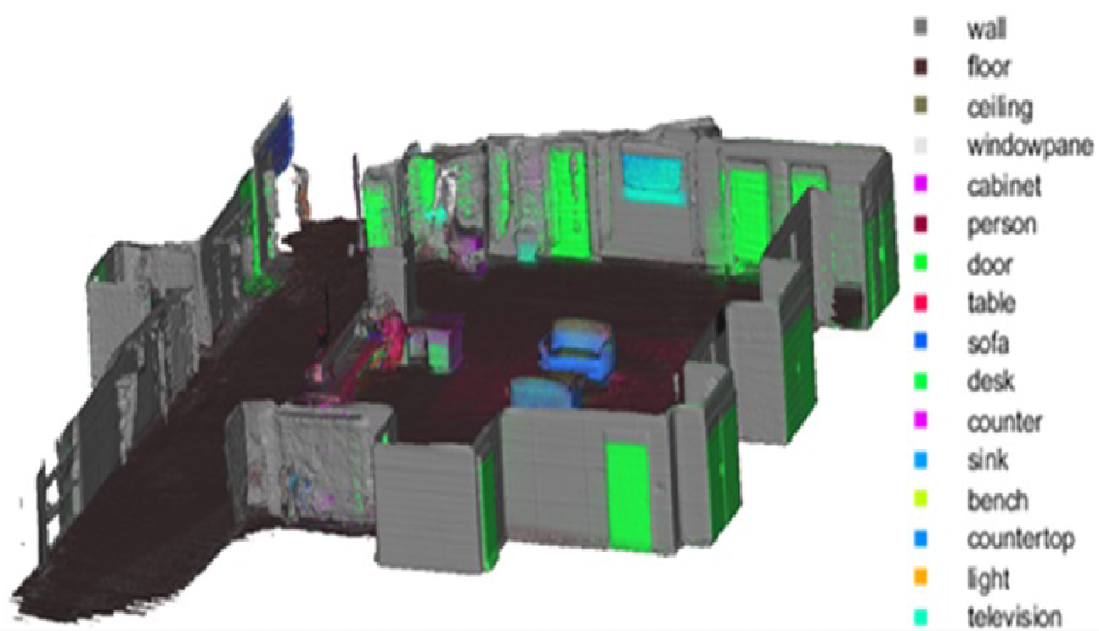 | 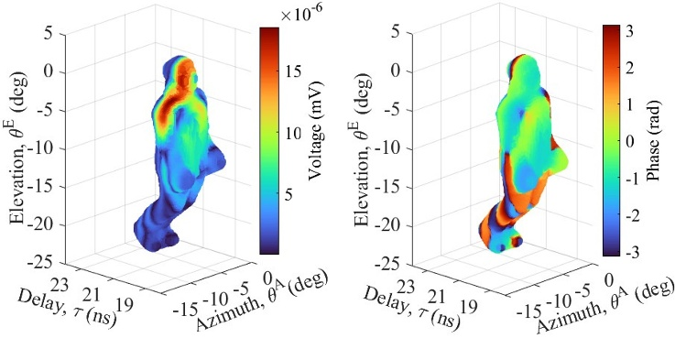

Figure 4.1 Example of multimodal sensing for sensing-assisted communication. Left: environment reconstruction and semantic segmentation obtained from collocated LiDAR and camera sensors. Right: human digital twin reconstructed from camera and LiDAR data and fused with RF measurements.

Due to limited study time, the sensing-assisted communication study can assume ideal prior knowledge as a starting point, focusing on estimation accuracy in dynamic scenarios, including MPC characterization and dynamic object tracking.

Observation 1: For high-fidelity environmental reconstruction and real-time digital twin updates, a primary function of ISAC is to generate and maintain an RF channel knowledge map. This map characterizes environmental reflections and can be overlaid on reconstructed environmental objects. Therefore, accurate estimation of delay, reflection angles (AoA/AoD), and their associated path power level is critical to support communication, such as proactive beam steering to avoid link failure.

Proposal 18: To evaluate sensing-assisted communication, the sensing aspect of the evaluation should prioritize Multipath Component (MPC) estimation, with a specific focus on MPCs exhibiting higher relative power to ensure reliable environment modeling. For the motion detection and prediction portion of the evaluation, the basic target detection and tracking evaluation can be reused.

Proposal 19: To evaluate the communication aspect of sensing-assisted communication, metrics include beamforming gain, beam alignment latency, and sensing overhead.

Performance Metrics and Sensing Requirement
In the RAN#111 meeting, the following sensing-related requirements have been agreed upon [4],
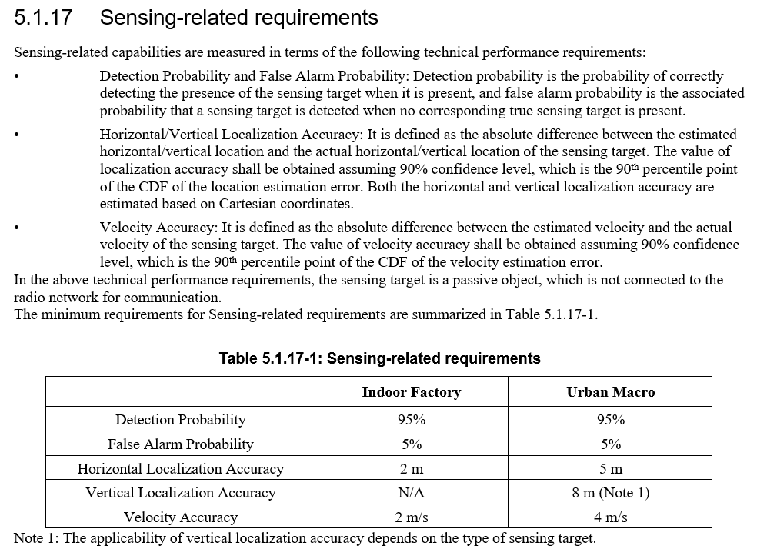

Proposal 20: The sensing performance metrics and requirements outlined in TR38.914 [4] can be used as a starting point for 6G sensing evaluation discussion. For some use-cases, e.g., AGV collision avoidance in an indoor factory, a more stringent range resolution of approximately 1 meter may be required.

Channel Model Extension

6.1 Human Respiration and Heartbeat

Micro-Doppler models the internal motion of a target, which is due to non-rigid body motion or vibration of a target, such as rotating blades of a drone, breathing, or heartbeat. Micro-Doppler is important for drone detection and classification, heart rate/breathing monitoring. Existing discussions on micro-Doppler characterization, such as those described in [5], primarily rely on simplified sinusoidal models for respiration and heartbeat. While such models constitute a reasonable and tractable baseline abstraction, they may not sufficiently represent the richer temporal structure observed in measurements. Therefore, this contribution proposes the physiologically based chest-motion model in [5] and [6], which provides a more realistic and flexible representation of human vital-sign micro-motion for ISAC evaluation.

6.1.1 Measurement setup
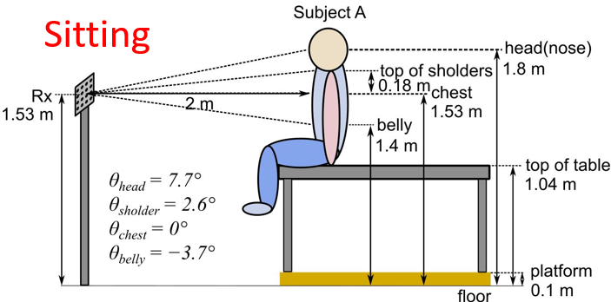 | 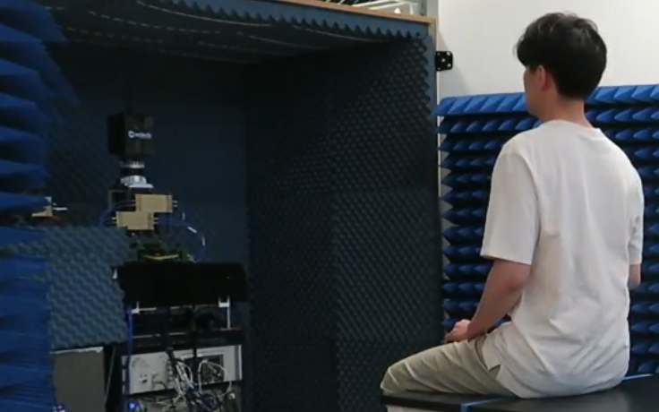
Figure 6-1: Measurement Geometry | Figure 6-2: Photograph taken during measurement campaign

The measurements utilized a single dual-polarized phased-array board with 64 microstrip antennas at the transmitter (Tx), and four of the same boards stacked side-by-side (256 microstrip antennas) at the receiver (Rx), a 360° azimuth camera, lidar, and vital sensors as described in [6] [7]. For the measurements described in this contribution, a human sat 2 m from the Rx. The setup and a photograph of the measurement campaign are shown in Figure 6-1 and Figure 6-2, respectively. Samples were collected every 26ms as the subject breathed at a normal rate for 25s, while vital signs were monitored. The measurement data comprised time of arrival, angles of arrival in the elevation and azimuth planes, path loss, and phase for each multipath component (MPC). After gating the MPCs around the chest area, the MPCs were complex summed.

6.1.2 Model
The proposed physiologically based chest displacement model [6] is composed of two components: one capturing respiration and the other capturing heartbeat-induced micro-motion. The model is defined as follows.

Respiration Motion
The breathing displacement function is modelled as a composite of a parabolic inhalation and an exponential exhalation profile:
$r_{breath}\left(t\right)=\left\{\begin{aligned}-\frac{r_{max}}{\left(T_{i}T_{e}\right)}t^{2}+\frac{r_{max}T}{T_{i}T_{e}}t, &t≤T_{i} \\ \frac{r_{max}}{1-e^{-\frac{T_{e}}{τ}}} \left(e^{-\frac{t-T_{e}}{τ}}-e^{-\frac{T_{e}}{τ}}\right), &T_{i}<t≤T\end{aligned}\right.$ Equation 6-1
Where $r_{max}$ is the maximum chest displacement due to breathing, $T_{i}$ is the inspiratory time $T_{e}$ is the expiratory time, ${T= T}_{i}+ T_{e}$ is the full respiration cycle period and $τ$is the exhalation decay constant.

Heartbeat Motion

The heartbeat-induced displacement is modelled using a sinusoidal function based on the subject’s heart rate:
$r_{heart}\left(t\right)=r_{h,max}\sin{2πt\frac{HR}{60} }$ Equation 6-2
Where $r_{h,max}$ is the maximum displacement due to cardiac motion and $HR$ is the heart rate in beats per minute. The total displacement of the chest is thus:
$r_{total}\left(t\right)=r_{breath}\left(t\right)+r_{heart}(t)$. Equation 6-3

6.1.3 Validation of the model

The RF measurements were used to extract parameters in Table 6-1

Table 6-1 Parameter for chest motion extracted from RF measurements at 28GHz
$$r_{max}$$ | 3.5mm
$$r_{h,max}$$ | 0.88mm
$$T_{e}$$ | $3.125$s
$$T_{i}$$ | 1.875s
$$τ$$ | $$Te/5$$
Excellent agreement between the phase (Figure 6-3) and the PSD (Figure 6-4) shows that we have accurately modeled the breathing and heartbeat displacement.

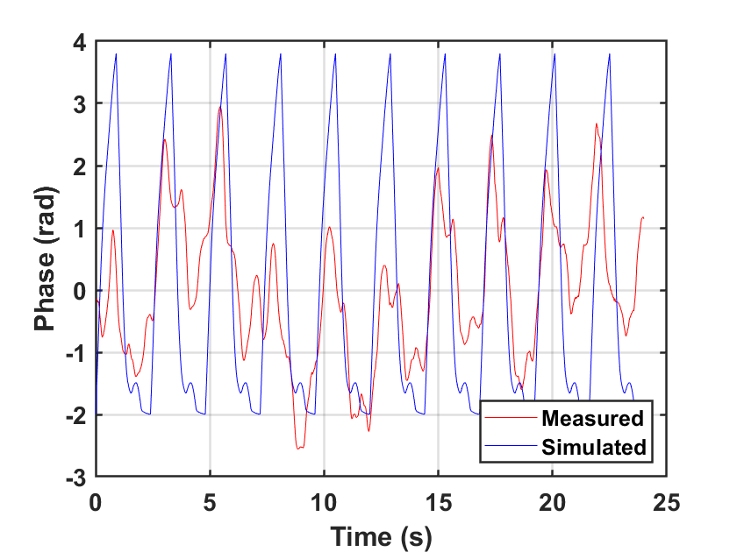 | 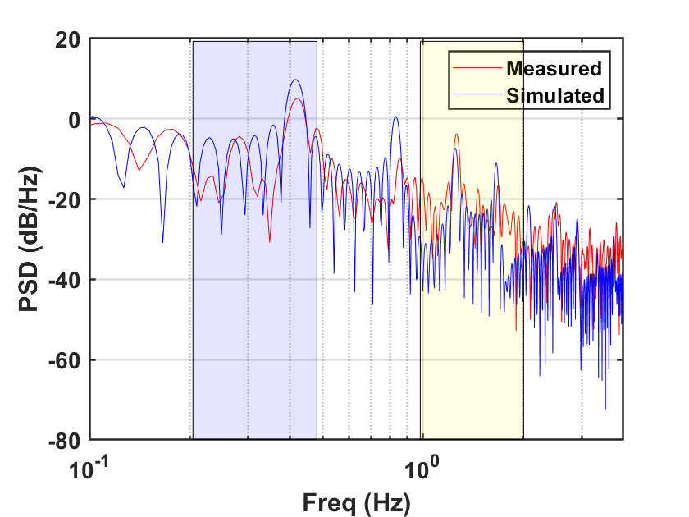
Figure 6-3: Phase comparison [6] | Figure 6-4: PSD comparison [6]
Proposal 21: Equations 6-1 to 6-3 provide a high-fidelity model of body movement during human respiration and heartbeat. The corresponding micro-Doppler shift can be computed as follows:

$f_{micro}=\frac{1}{ λ }[-\frac{dr_{total}\left(t\right)}{dt} \vec{r_{1}}(t)-\frac{dr_{total}\left(t\right)}{dt} \vec{r_{2}}(t) ]$,
where $λ is the wavelength,{ r}_{total}\left(t\right) is the total displacement of the chest, and \vec{r_{1}}(t)$ and $\vec{r_{2}}(t)$ are the unit radial vectors from TX to the human subject and from RX to the human subject, respectively

6.2 RCS Modeling for Vehicles with Different Sizes

In the Rel-19 channel model study, the RCS of a vehicle has been modeled [8]; however, the vehicle's large-scale parameter, which represents an object's overall reflectivity, is fixed regardless of vehicle size. At NIST, we conducted measurements on three different-sized vehicles shown in Figure 6-5. These include a small vehicle (Sedan), a medium-sized vehicle (SUV), and a large vehicle (Van), with their sizes and dimensions illustrated in the figure.
The measurements were conducted at 28 GHz. In Table 6-2, the mean RCS values extracted from measurements are compared to the 3GPP model. The values in the table show that vehicle size significantly impacts the resulting mean RCS value ($σ_{M}$). Therefore, to model vehicles of various sizes, including Type 1/2 (Passenger Vehicle) and Type 3 (Truck/Van/Bus), within the 6G ISAC evaluation assumptions, it is important to account for the distinct physical characteristics of these vehicle types.

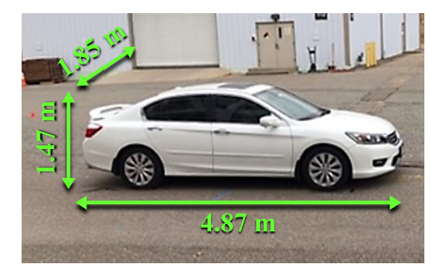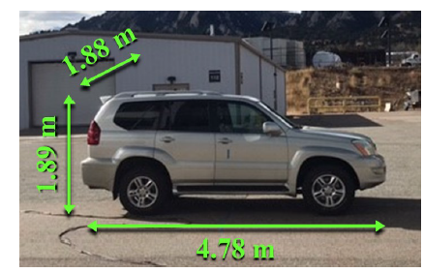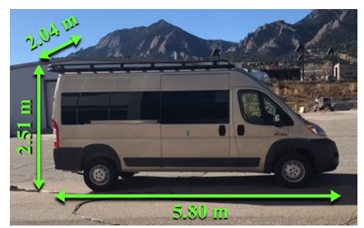
Type 1: Sedan Type 2: SUV Type 3: Van
Figure 6-5: Target Measurements for Vehicles of Three Different Sizes

Table 6-2: Measured mean RCS values compared to the 3GPP RSC model
Vehicle  Type | 10lg($σ_{M}$) dBsm  measured | 10lg($σ_{M}$) dBsm  in TR 38.901
Type 1 (Sedan) | 9.98 | 11.25
Type 2 (SUV) | 13.36
Type 3 (Van) | 20.88

Proposal 22: Different mean RCS values ($σ_{M}$), together with the radiation pattern model defined in TR 38.901, can be used to represent vehicles of various sizes, including sedans, SUVs, and vans.

Conclusions
In this document, we discussed deployment scenarios, channel model extensions, and evaluation metrics and KPIs, along with the following proposals:
Proposal 1: The following sensing modes for each baseline use case could be considered:

Sensing Target | Indoor or Outdoor | Scenario | Carrier Frequency | Sensing Mode
UAV | Outdoor | UMa-AV, SMA | 4 GHz, ~7 GHz, 30 GHz (for UMa-AV only) | TRP monostatic, TRP-TRP bistatic
Human | Outdoor | UMa | 4 GHz, ~7 GHz, 30 GHz | TRP-UE bistatic, UE-TRP bistatic
 | Indoor | Indoor Hotspot | 4 GHz, ~7 GHz, 30 GHz | TRP-UE bistatic, UE-TRP bistatic, TRP monostatic
Vehicle | Outdoor | Urban Grid, Highway | 4 GHz, ~7 GHz, 30 GHz (for Urban Grid only) | TRP-UE bistatic, UE-TRP bistatic,  UE monostatic, UE – UE bistatic
AGV | Indoor | Indoor factory (SH) | 4 GHz, ~7 GHz, 30 GHz | TRP monostatic, UE-TRP bistatic, TRP-UE bistatic

Note that, in the urban Grid and Highway case, the UE can be an RSU-type UE or a vehicle UE.

Proposal 2: The 5G-A ISAC evaluation methodology can serve as a starting point for discussing 6G sensing evaluation.
Proposal 3: Consider Table 3-1, which is based on TR38.914 and TR38.901, for sensing deployment and UE distribution for each scenario.
Proposal 4: For target modeling, we propose Table 3-2 for consideration.
Proposal 5: When evaluating UE-involved sensing, static UE sensing can serve as a baseline and is more likely to produce reliable results.
Proposal 6: Sensing with UEs in motion should be further evaluated in the study to represent both pedestrian and vehicle UEs.
Proposal 7: For 6G sensing evaluation, the TRP antenna configuration can use the 5GA agreement as a starting point.
Proposal 8: For the CPE and handheld UE, antenna configurations can be based on the 6GR UE antenna configurations [1].
Proposal 9: For other types of sensing UEs, such as RSU-type UE and vehicle UE, TR37.885 can be used as a discussion starting point
Proposal 10: For TRP monostatic sensing, the simulation assumptions, such as self-interference modeling, antenna isolation, and maximum transmit power, can reuse the 5G-A ISAC evaluation assumptions as a starting point.
Proposal 11: For the evaluation of UE-based sensing, the following modeling assumptions should be considered:
- Baseline: Ideal knowledge of the UE’s state (location, velocity, or orientation) may be assumed as a starting point.
- Realistic Scenarios: To reflect practical deployments, modeling errors and uncertainties for these parameters (e.g., location, velocity, or orientation) should be incorporated into the evaluation.
Proposal 12: To ensure a comprehensive and realistic evaluation of sensing performance, the modeling framework shall include:
- Baseline: Ideal time synchronization to establish an upper-bound performance reference.
- Realistic Scenarios: To reflect practical scenarios, modeling synchronization errors among sensing nodes should be incorporated into the evaluation.
Proposal 13: To facilitate consistent cross-company evaluation, a common baseline for sensing-related evaluation parameters should be established, including 1) Participated sensing nodes, 2) Beam configurations at each sensing node, 3) Sensing reference signal and its RE mapping, 4) Timeslot configuration, and 5) CPI duration and its periodicity.
Proposal 14: The 6G ISAC evaluation assumption should include modeling dynamic clutter and platform-induced non-stationarity to accurately capture the challenges of target detection in non-stationary sensing environments.
Proposal 15: Incorporate target-specific micro-motion models into the evaluation assumptions to enable the assessment of zero-velocity targets, including hovering UAVs and stationary humans.
Proposal 16: Incorporate target-specific micro-motion models into the evaluation assumptions to support the assessment of target identification applications based on micro-Doppler signatures.
Proposal 17: RAN1 should evaluate the effects of dynamic clutter, moving sensing platforms, and micro-Doppler on both single-CPI detection and target tracking.
Observation 1: For high-fidelity environmental reconstruction and real-time digital twin updates, a primary function of ISAC is to generate and maintain an RF channel knowledge map. This map characterizes environmental reflections and can be overlaid on reconstructed environmental objects. Therefore, accurate estimation of delay, reflection angles (AoA/AoD), and their associated path power level is critical to support communication, such as proactive beam steering to avoid link failure.

Proposal 18: To evaluate sensing-assisted communication, the sensing aspect of the evaluation should prioritize Multipath Component (MPC) estimation, with a specific focus on MPCs exhibiting higher relative power to ensure reliable environment modeling. For the motion detection and prediction portion of the evaluation, the basic target detection and tracking evaluation can be reused.

Proposal 19: To evaluate the communication aspect of sensing-assisted communication, metrics include beamforming gain, beam alignment latency, and sensing overhead.

Proposal 20: The sensing performance metrics and requirements outlined in TR38.914 [4] can be used as a starting point for 6G sensing evaluation discussion. For some use-cases, e.g., AGV collision avoidance in an indoor factory, a more stringent range resolution of approximately 1 meter may be required.

Proposal 21: Equations 6-1 to 6-3 provide a high-fidelity model of body movement during human respiration and heartbeat. The corresponding micro-Doppler shift can be computed as follows:

$f_{micro}=\frac{1}{ λ }[-\frac{dr_{total}\left(t\right)}{dt} \vec{r_{1}}(t)-\frac{dr_{total}\left(t\right)}{dt} \vec{r_{2}}(t) ]$,
where $λ is the wavelength,{ r}_{total}\left(t\right) is the total displacement of the chest, and \vec{r_{1}}(t)$ and $\vec{r_{2}}(t)$ are the unit radial vectors from TX to the human subject and from RX to the human subject, respectively

Proposal 22: Different mean RCS values ($σ_{M}$), together with the radiation pattern model defined in TR 38.901, can be used to represent vehicles of various sizes, including sedans, SUVs, and vans.

References

[1] | R1-2601752, "Final Report of 3GPP TSG RAN WG1 #124 v1.0.0," St Julian's, Malta, April 2026.
[2] | A. Bodi, S. Berweger, R. Caromi, J. Bang, J. Senic and C. Gentile, "AI-Based Environment Segmentation Using a Context-Aware Channel Sounder," in 2024 18th European Conference on Antennas and Propagation (EuCAP), 2024.
[3] | C. Gentile, R. Caromi, S. Berweger, S. Blandino, A. Bodi and J. Chuang, "AI-Driven Fusion of Multimodal Channel Sounder Data for RF Heatmap Segmentation," in ICASSP 2026 - 2026 IEEE International Conference on Acoustics, Speech and Signal Processing (ICASSP), 2026.
[4] | 3GPP TR 38.914, "Study on 6G Scenarios and Requirements (Release 20)," 2026-03.
[5] | V. C. Chen, The micro-Doppler effect in radar, Artech house, 2019.
[6] | S. Mukherjee, B. M. Hardy, G. J. Skidmore, T. Chawla, J. Bang, J. Chuang, J. Senic, S. Berweger, S. Blandino and C. Gentile, "Animating Vital Signs in Radar Simulations: Comparing Physical Optics Against 28.5 GHz Channel Measurements," in 2024 IEEE Radar Conference (RadarConf24), 2024.
[7] | 3GPP TSG-RAN WG1 #116 R1-2400175 National Institute of Standards and Technology, "Power Calibration for Radar Cross Section (RCS) Measurement," February 26th – March 1st, 2024.
[8] | 3GPP TR38.901, "Study on channel model for frequency from 0.5 to 100 GHz (Version 19.0.0)," 2025-07.
[9] | RP-260282, "Revised SID: Study on 6G Radio," Fukuoka, Japan, March 2026 (RAN#111).
[10] | 3GPP TR 38.765, "Study on Integrated Sensing And Communication (ISAC) for NR (Release 20)," 2026-02.
[11] | R1-2601697, "Collection of agreements for R20 6GR evaluation assumptions," Gothenburg, Sweden, February 2026.

